

**PROJECT 3**

**TERM 3-INDIVIDUAL REPORT**



August 26, 2022

cAPE pENINSULA uNIVERSITY

Warren Jaftha-219005303

Contents

INTRODUCTION 1

CODING PROGRESS 2

Trello Board 2

Work Completed 2

New Coding Progress 9

USER INTERFACE DESIGN 27

# INTRODUCTION

The beginning of the 3rd term saw us completing our main functionality of our application. The application that we were designing was a **Notepad** application which was to save notes and store it in an online database and to also give the user the ability to **edit** or **delete** the note that they have inserted into the database. Upon completing these main functionalities, I have decided to include extra functionalities that would better our app which was a Calendar function which could save dates and times of different events.

# CODING PROGRESS

For Term 3 I have made tremendous progress when it came to coding new functionalities for our application. Adding the new calendar function took a total of 18 pages in total to be coded

## Trello Board

As the leader of the assignment, I have created a Trello board to help keep track of both our coding progress which you will see screenshots of in my report as well as just general tasks that needed to be completed for the group. This will benefit not just me but also my group to help eliminate confusion and keep us on track.

Link: <https://trello.com/b/8quSaIGy/notepad-app-project-3>

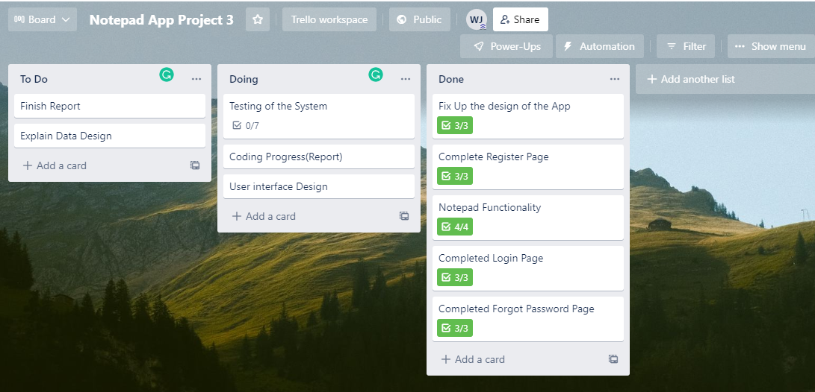Screenshot:

## Work Completed

**SignUp.java**

**EXPLANATION**

This code is basically responsible for the back-end functionality of our Sign-Up page. So, what happens on this page is that the user creates an account using this page to which the software stores it on the **Firebase database** which we have created.

after this the software will send the user an email to verify their account so that they can login

After this the software will send After the user has created an account then the page sends the user back to the login page so that they will have to login

**SignUp.xml**

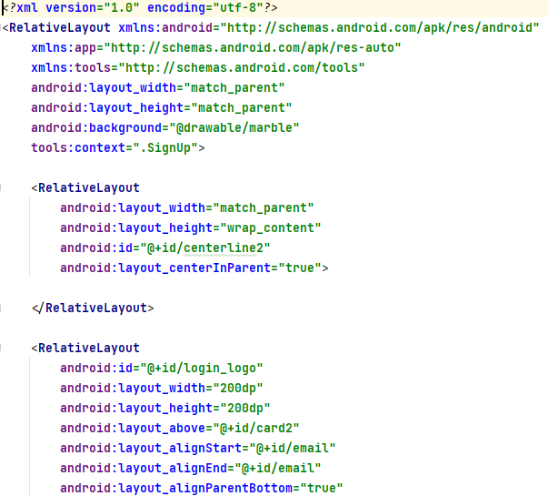

**EXPLANATION**

This code that I have presented in the xml file is the design code for the page and this is how it will look when viewing it on a phone. Note that this is not the final design this is just the prototype design that we are wanting to present.

Contains a Header, 2 Edit Text as well as a button to take the user to the signup page and a link and the bottom to take the user back to the login page.

## New Coding Progress

**Calendar.java**

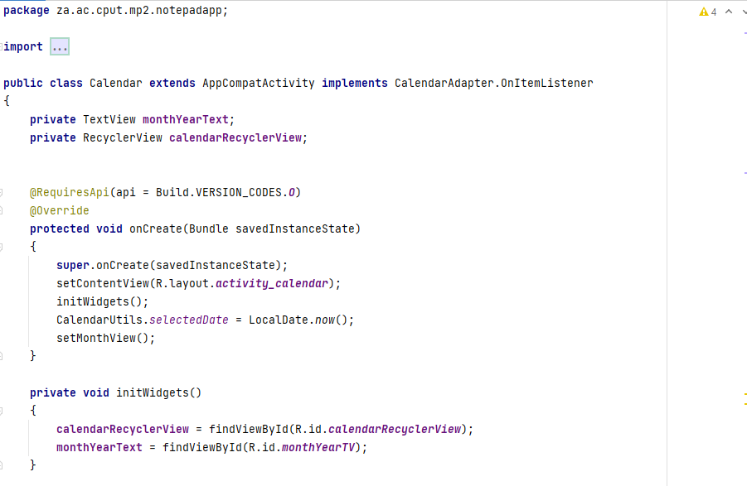

**EXPLANATION**

This code that is presented for this section was used for the back-end functionality of my Calendar page and is basically responsible for setting the month, the weeks, and the days in correct gride layout as well as allowing the user to select any dates that they want. As well as providing a proper navigation so that the user can move freely between the calendar, the notes, the login and register page.

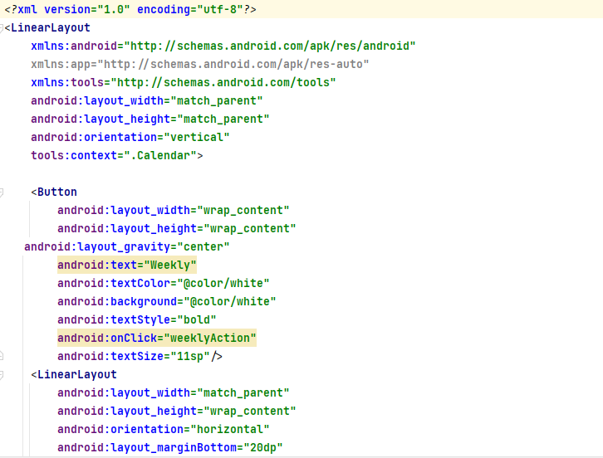**Activity_Calendar.xml**

**EXPLANATION**

This code that I have presented in the xml file is the design code for calendar page the image that I have provided is the design that the user will see when viewing the base calendar function.

The page contains a gridview layout where the numbered days are placed along with the navigation bar and 2 directional buttons to switch back and forth between the months

**CalendarAdapter.java**

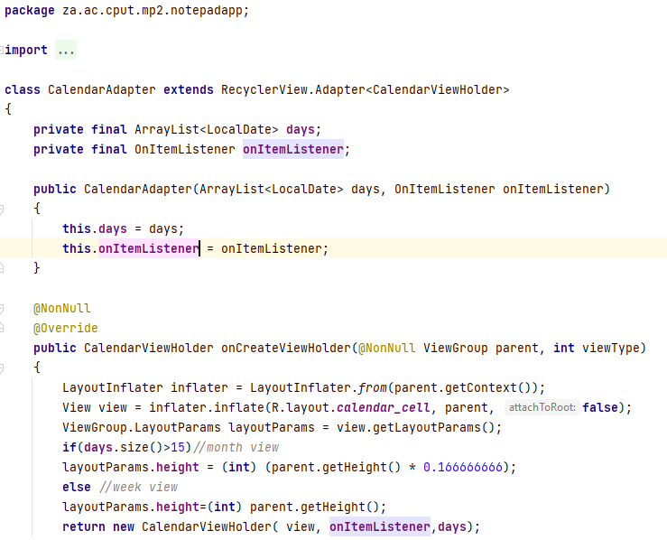

**EXPLANATION**

This page is basically responsible for storing all the base dates of each month in a array list. And contains multiple functionalities coded within it for example when the user clicks one of the dates then the background of the “day_cell” changes color to indicate that a particular day has been selected. This page has a last design functionality which is determining the layout of each month based on the number of days each one possesses.

**CalendarUtils.java**

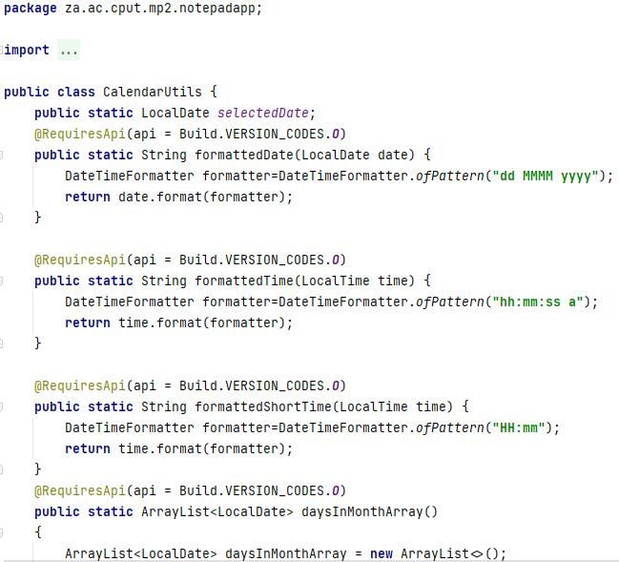

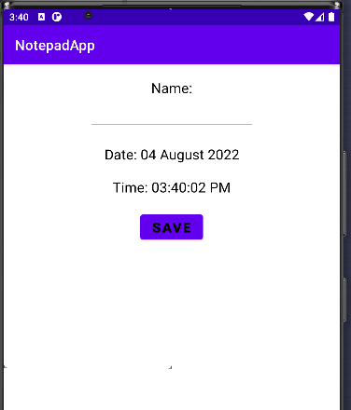

**EXPLANATION**

This page called **CalendarUtils** is responsible for assigning a Local Date to the calendar page. So basically, what the function is responsible for is that it gets whatever is the current date on the local system which is the computer or laptop that you are using and assigns it to the calendar function, what that means is when you open the calendar page then it takes you to the current month as well as the current day within the week that your system is currently on. This page also retrieves certain functions that were specified in the CalendarViewHolder page

Another this that this page is responsible for is determining the format that the Days and months should be displayed for example “dd :MMMM: yyyy” means display the day first then the month and then finally the year then with time as well “hh:mm:ss a” this means simply to display hours, minutes and then finally seconds.

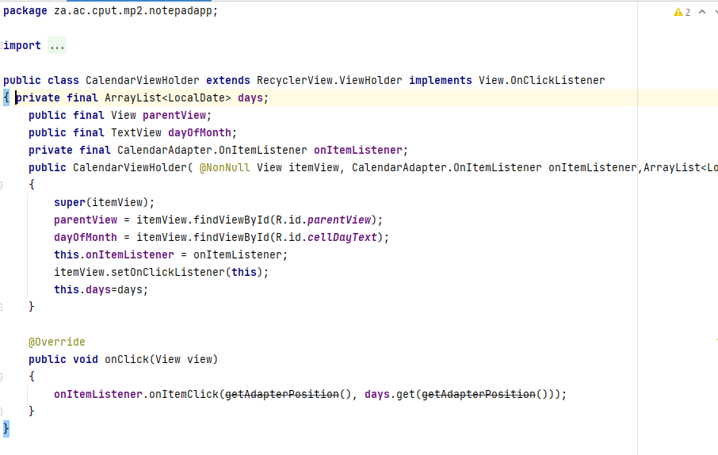**CalendarViewHolder.java**

**EXPLANATION**

This page’s main responsibility of this page is very simple as it is used to house the methods that was used in the Calendar Page as well as the Calendar Adapter page. It doesn’t just house functionality methods but its also houses methods related to design that will be used in other parts of the app.

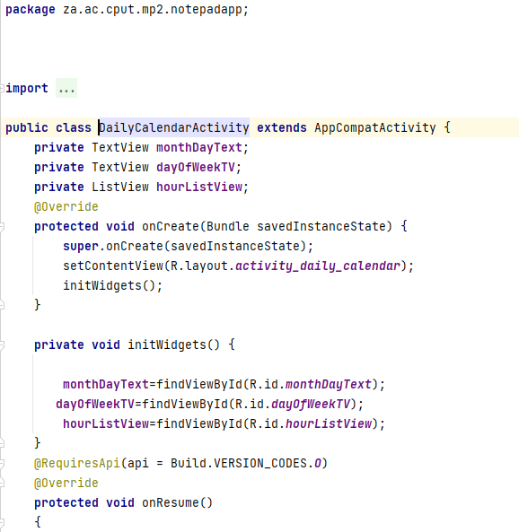**DailyCalendarActivity.java**

**EXPLANATION**

This page is responsible for switching to the daily view of the calendar and allowing the user to choose more carefully about what time they want to add an event into the calendar.

As you can see by the code there is a setDayView and a setHourAdapter these 2 functions are responsible for setting the Day and the Hours in the day which is 24 into an array list.

**Activity_daily_calendar.xml**

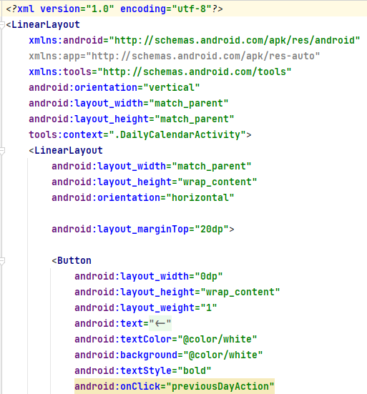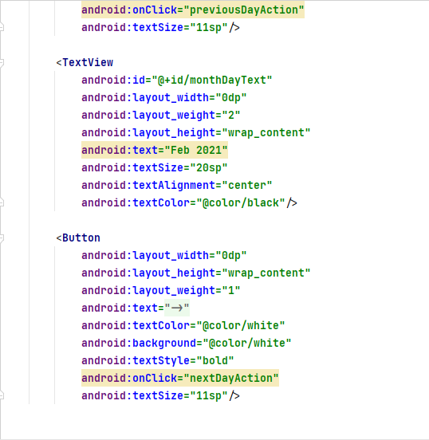

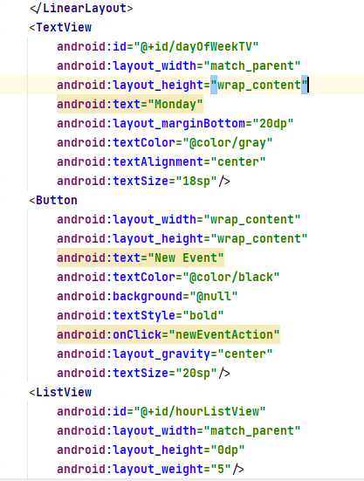

**EXPLANATION**

The xml code will give the following look to the day selection option on the calendar. The page contains 3 buttons one for adding a new event and 2 others that help the user switch between days. Under the event button is a scroll view which can be swiped upwards or downwards so that the user can select a time. The times is displayed on the left-hand side.

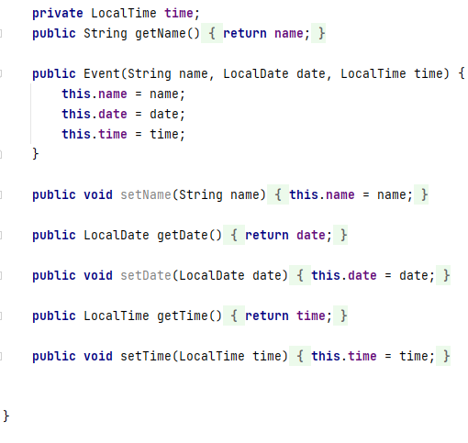**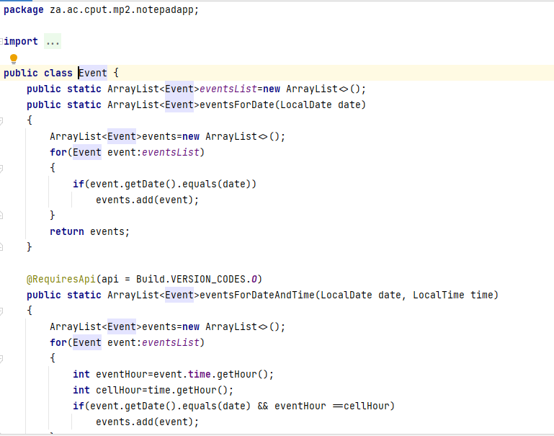Event.java**

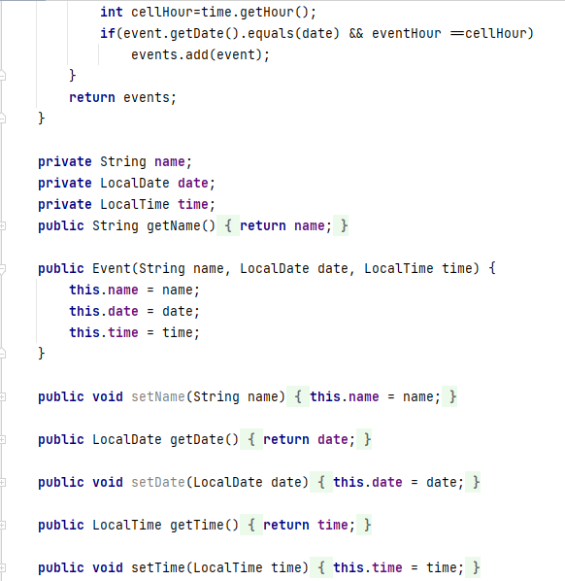

**EXPLANATION**

This page’s main functionality revolves around capturing the name of the event entered, the local time that the event was saved on and the date. Once the event has been added into the calendar it will be displayed in the array next to the time that was chosen for example

**EventAdapter.java**

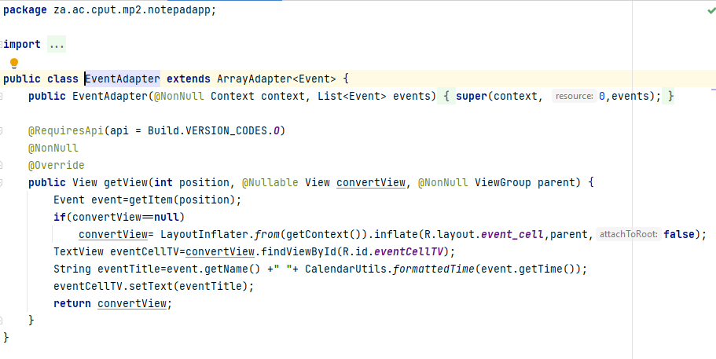

**EXPLANATION**

This event adapter main functionality is to take the place as structural design pattern now this allows incompatible objects to collaborate. The Adapter acts as a wrapper between many objects created for the event page. What the page does is that it catches a call for one object and transforms them to format and interface recognizable by the second object.

**Menu.xml**

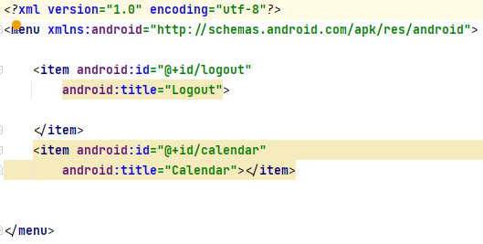

**EXPLANATION**

This code is responsible for the navigating between the calendar page, the login as well as the notes page. The navigation icon that is being used for the design is called Kebab Menu.

When the button is clicked 2 options is shown the logout and the calendar the logout takes you to the login page whereas the calendar takes you to the calendar page.

When on the calendar page and the menu icon is clicked then it will show the notes text this will take you back to the notes page

# USER INTERFACE DESIGN

**Registration Page**

The first page that I was responsible for designing was the Registration page. When the user wants to create a new account, this is the page that they will be greeted with.

The page contains 2 headers. One with the font of approximately the size of 48 which reads “Quill” the inner layer of the word has a white color, and the outer border is a shade of purple called indigo with the following hex code of #4B0082.

There is 2 edit text where the user can input their information. One is for the email of the user and the other is for the password.

The edit text has a shade of grey with text inside of them that’s the color black to indicate to the user what needs to be inserted into them.

The user also has the option to hide or display their password that they are typing in as displayed by the following eye icon shown on the right.

The Entire Registration page is coded on a relative layout design what this means to put it in a simple term is that it is arranged in order from top to bottom underneath one other.

The button is center with a blue violet color with a hexadecimal code of #9417E2 with text inside reading “Sign Up”

Under that is a text reading “Want to Login? Click Here!” this will take the user to the login page

The Edit text, the button and the text link are placed on a card view which is the color white *to make the buttons and edit text stand out.*

The background is an image designed on Adobe illustrator with a mixture of purple and white to create a nice split complementary color scheme that works well with the other elements of the page

**Calendar Page**

This is the view of the main calendar page that the user will see when they would like to place a task that is due on a particular day.

The layout of the page is as follows:

On the top you have the heading of the page “NotepadApp” to the right the user is presented with the kabab navigation icon so that they can switch between pages. The color of the blue navigation bar is a shade of blue called Cobalt blue with the following code #0047AB

Under the navigation bar is a button reading “Weekly” the wording is typed in a classic Arial Font. This button can be clicked to switch to the weekly view. The week selection button is the month heading including the year.

To the left and right is button with directional arrows these 2 buttons are used for switching between the months

That is the top part of the page the bottom part of the page houses the calendar days sorted in an array method. The user will be able to choose which day they would like to pick and when a day is chosen then it is highlighted in a grey color to indicate this.

**Daily Page**

After the user switches to the weekly view, they have the option on that page to switch to the daily view where the arrow is indicating. Once the user clicks the daily button then they are taken to the daily selection page.

Here the user will have an in-depth view of each day within the calendar being free to choose more precisely what time within the day they would like to place a task they can do this by pressing the “NEW EVENT” button that will allow then you place an event.

The daily page is structured the same way that every calendar page is except there is one major change which is the times that is displayed under the “NEW EVENT” button the times go from 00:00-23:59 so the user can choose any one of those times to input a task.

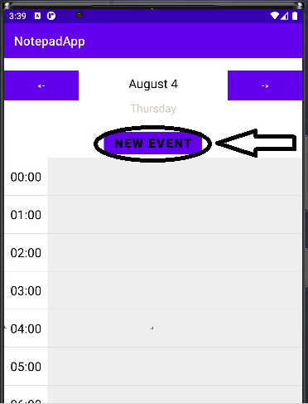

The time on the left is displayed in the hh:mm format to the left of the time is rectangle blocks with gray color and when an event is placed in the gray blocks it will have the following look. As seen in the image when the task is inserted it will be displayed in a blue block with white outlining

# Data Design

## Purpose of the Database

The database that me and my team decided to use for our application is called Google Firebase is a application development software that allows developers to code applications with different Operating Systems such as IOS and Android. One of the functions with firebase is that it offers database features with allows you to create an online cloud database to store information that’s to do with your application.

The database in our application is used to store Users profile information such as their user UID, email and their password. The other purpose that our database serves is to save the Notes that the users had typed out with all their different tasks into the database and link it to the profile. The registration page aid in the user inserting their information into the database and the Calendar page allows the user to add an event to a certain day.

## Find and organize the information Required

### First Normal Form

|  |  |  |  |
| --- | --- | --- | --- |
| **UID** | **Email** | **Password** | **Notes UID** |
| g5uU8HcEKmO93Akt9eFmQklgd4d2 | warrenjaftha16@gmail.com | 01234567 | Dww31uz69TeoFHIhsWYE |
| Ufcm3gnjyqhxtY9czqKPgJvkgVk2 | nawaazamien9@gmail.com | 12345678 | eghdGBJ432jamr$fqpfBBW |

### Second Normal Form

|  |  |
| --- | --- |
| **UID** | **Notes UID** |
| g5uU8HcEKmO93Akt9eFmQklgd4d2 | Dww31uz69TeoFHIhsWYE |
| Ufcm3gnjyqhxtY9czqKPgJvkgVk2 | eghdGBJ432jamr$fqpfBBW |

|  |  |
| --- | --- |
| **Email** | **Password** |
| warrenjaftha16@gmail.com | 01234567 |
| nawaazamien9@gmail.com | 12345678 |

### Third Normal Form

|  |  |
| --- | --- |
| **UID** | **Notes UID** |
| g5uU8HcEKmO93Akt9eFmQklgd4d2 | Dww31uz69TeoFHIhsWYE |
| Ufcm3gnjyqhxtY9czqKPgJvkgVk2 | eghdGBJ432jamr$fqpfBBW |

|  |  |
| --- | --- |
| **Email** | **Password** |
| warrenjaftha16@gmail.com | 01234567 |
| nawaazamien9@gmail.com | 12345678 |

|  |  |
| --- | --- |
| **UID** | **UID Password** |
| g5uU8HcEKmO93Akt9eFmQklgd4d2 | 01234567 |
| Ufcm3gnjyqhxtY9czqKPgJvkgVk2 | 12345678 |

## Entity Relationship Diagram

The Diagram might not be big but this diagram perfectly illustrates the relationship between our different entities there are many primary keys such as the UID and Register_ID this is to keep track of the users.

The next diagram that I will be displaying is a Data Flow Diagram this will show how data flows throughout our application.

## Data Flow Diagram

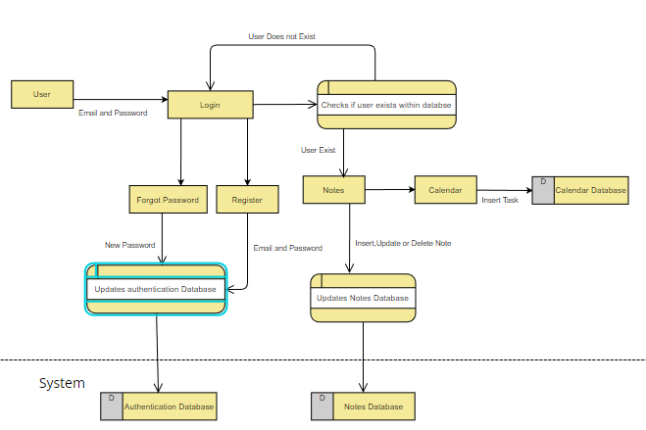

This diagram indicates how dataflows throughout our systems.

If the user doesn’t have an account or lost their password

The user starts the application by login if they have an account then they sign in the system will check if the user exists or not if the user doesn’t exist then the system returns the user back to the login page.

The user then has an option to either register for an account, this option is only if the user doesn’t have an account. The user should then enter their email and password through which the authentication database gets updated

If the user does already have an account, then the user should choose forgot password where the user enters their email and then the process will go forward where they would be inserting their new password to which the authentication database is updated.

If the user does have an account and can login

If the user does have an account and can log in successfully then the application will take the user to the Notes page. Once on this page then the user can insert a title to their note and add information to their note. The app will then add the information to the Notes Database. The user has the choice to either add, update, or delete info.

The user then also has the option to switch to the calendar page where they can switch between dates and insert tasks to be completed on those days. The tasks are then added to the Calendar Database.

## Insert, Update and Delete

The application allows users to insert, update and Delete information

At first the user is present with a blank notes page with a plus symbol when the icon is pressed the user is able to add a note

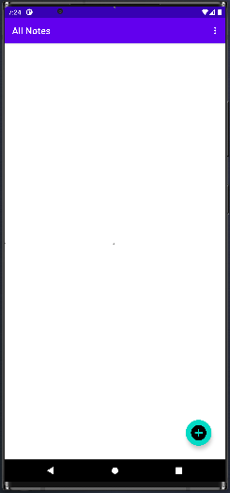

Will look like this

The user will then insert their information. The title and the details for the note

Once inserted it will look like this

And will be displayed in the database

The user also has the option if they want to edit or delete the text that is in the database or note which will be further showcased in the video that will be presented when the text is edited or deleted then it is done so in the database as well.

## Connection between registration and Database

The registration page has a very important connection with the authentication database. When new users want to create a new account, they must insert their information into the registration page then once submitted the registration page sends the information to the database where it is then stored.

The firebase software will then send a confirmation email to the user’s mail where they will have to verify that the email is theirs. Once verified the user will be taken to the login page where they will need to sign in.

# TESTING

Functionality Testing

the functionality testing of the registration page works perfectly just as the requirements states the registration page can add information of the user into the authentication database

Recoverability testing

The system can recover from a variety of input mistakes such as:

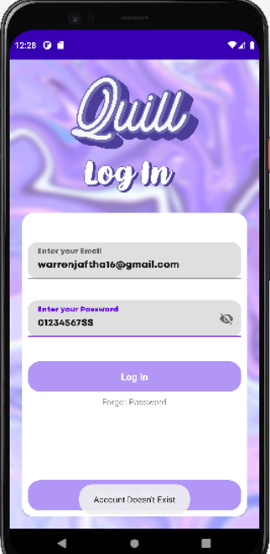

When the user inputs the incorrect password or email the system gives a notification message saying that the account doesn’t exist.

This type of testing also falls under the category of Handling Exceptions this proves that our app doesn’t collapse when you the incorrect information is inserted rather it displays a message to alert the user to correct their information

When the user signs up for an account and they haven’t verified it but they try to login then it will show an error message like this. This is to indicate to the user that hey should verify their email first in order to be let into the application to use its functionalities

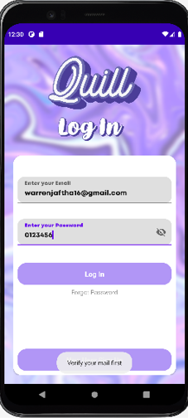

GRAPHICAL USER INTERFACE (GUI)

The GUI of the registration functions as planned all the buttons on the page works, the navigation bar works as well. It allows users to be taken to other pages such as the login or forgot password

both text fields allow the user to enter text within them.

TESTING FOR COMPATIBILITY

Our system can only function on phones, it is unable to function on browsers or on any other type of medium. The app however can function on any phone no matter what hardware, but it must have an android Operating System.

Our database of our app only works with Google software as we are using firebase software so it will only function with google based apps and no other.

# CONCLUSION

This brings up to the end of the report. In this report I spoke a lot about our application. What it was about, what’s its functionalities were as well as displaying code. I Spoke about the User Interface design as well as the data design explaining how the data flowed between the different pages. This report was to inform the reader so that they could get a better understanding of the problem that our application was trying to solve.